September 30, 2021

Ms. Eraina Ortega
CalHR
1515 S Street, North Bldg., Suite 500
Sacramento, CA 95811-7258

Dear Ms. Ortega,

I am writing to urge CalHR to provide an extension of supplemental paid sick leave to all SEIU Local 1000 represented employees.

Leading the way, California was one of the first states to pass a pandemic paid sick leave requirement for employers. SB 95 went into effect on March 29, 2021 (retroactive to January 1, 2021), extending and expanding the requirements for employers to provide supplemental paid sick leave (SPSL) to employees impacted by COVID-19. This leave has proven to be a tremendous benefit to our represented employees, who have worked tirelessly through the pandemic to keep the vital services of California running.

However, SB 95 is set to expire on September 30, 2021 and Governor Newsom’s office has not indicated there is any plan to extend the law or otherwise mandate California SPSL beyond the end of September. This is not acceptable.

SEIU Local 1000 is urging CalHR to again lead the way by enacting their own SPSL measures beyond September 30th to ensure our state workforce is protected. The emergence of the COVID-19 Delta variant means that the virus continues to be a public health threat to all Californians and their young children, regardless of their vaccination status, presenting a real continual need for SPSL for state employees.

Thank you for your consideration of this important matter.

Sincerely,

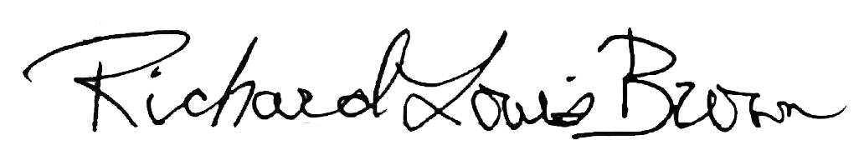

Richard Louis Brown
President, SEIU Local 1000

