Actuary Incentive Award Task Force Recommendations Report
[Dec 2022]

Introduction
As part of the Side Letter Agreement in to the current Memorandum of Understanding (MOU) dated January 2, 2020 through June 30, 2023 between Service Employees International Union, Local 1000 (Union) and the State of California (State) agreed to establish a taskforce to explore the feasibility of an incentive program for employees in the newly consolidated Actuary Series.

‘Within sixty (60) days of the first day following the pay period of the State Personnel Board’s approval, the State and the Union shall convene a taskforce to study the feasibility of an Incentive Award Program for the Actuary classification series. The State and the Union shall have an equal number of participants, not to exceed five (5), unless otherwise mutually agreed to. The State and Union shall each designate a chair. Taskforce members shall serve without loss of compensation. The taskforce will meet every other month
through December 2022, upon which any agreed recommendations will be made by the Taskforce to CalHR. Meeting frequency can change upon mutual agreement of the chairs. The scope of the taskforce is to study and develop a recommendation regarding an Incentive Award Program for the Actuary classification series that benefits the State and the employees. Each agenda shall be mutually determined prior to each meeting, but normally no less than five (5) business days before the meeting.’

This document serves to record the considerations of the taskforce and provide recommendations to CalHR.

Meeting Dates: The taskforce convened on the following dates: July 19, 2022, August 23, 2022, September 21, 2022, October 20, 2022, December 6, 2022, and December 21, 2022.

Taskforce Members:
Union Representatives
Susan Rodriguez, Chair, Bargaining Unit 1
Stuart Bennett, District Bargaining Unit Representative, Unit 1, Actuary Senior, CalPERS

Julian Robinson, Actuary Senior, CalPERS
David Clement, Actuary Senior, CalPERS
Matt Fisher, SEIU Local 1000, Contract Staff

State Representatives
Brian Lin Walsh, Labor Relations Officer, CalHR
Lynne Wehmueller, Chief Actuary, Rate Regulation Branch, CDI
Julie Morgan, Labor Relations Officer, CalPERS
Jorrell Sorensen, Director of Employee Relations, State Fund
Lory Mercado, Labor Relations Specialist, CalSTRS
Cindy McConnell, Personnel Officer, CDI

State Employee Population Covered
The recommendations of this task force apply to employees in the Actuary Series employed at California Public Employees’ Retirement System (CalPERS), the State Teachers’ Retirement System (CalSTRS), State Compensation Insurance Fund (SCIF), the California Department of Insurance (CDI), the California Department of Managed Healthcare (DMHC) and the California Department of Healthcare Services (DHCS).
Rationale – Recruiting and Retaining Employees in the Actuary Series Promotes Public Interest

The California Supreme Court has ruled and confirmed that employee bonuses or additional compensation does not violate the California Constitution’s prohibition on gifts of public funds as recruiting and retaining well qualified and proficient State employees promotes the public interest.

Actuaries for California secure State employee retirement benefits, fund State employee healthcare benefits, and regulate insurance companies to make sure that consumers are protected and the premiums Californians pay for many insurance products (such as life, automobile, homeowners, and workers compensation insurance) are not excessive, inadequate or unfairly discriminatory.

The Minimum Qualifications for the Actuary classification requires an Associateship with the Society of Actuaries (SOA), Casualty Actuarial Society (CAS), or an actuarial organization for which the SOA or CAS honors exam credits.

Class Description
The Actuarial series specification describes six classifications in California state service which perform and/or supervise a wide variety of actuarial work in the following specialties: complex financial risks, retirement, casualty insurance, health insurance, life insurance, long-term care, or pension systems.

Employees in this series may conduct actuarial analyses or valuations to verify the accuracy and reasonability of premiums/contributions, rates, reserves/liability, or other related factors; conduct cash flow testing and analyses of adverse market conditions to ensure appropriate fund reserve levels; review actuarial support for rate filings to determine if the proposed rates have been determined in a manner consistent with actuarial principles and standards of practice, and are in compliance with statutory requirements; analyze organizational and/or fund liability/reserve positions and reasonability using actuarial, statistical and economic principles, practices and methods; conduct or review present value valuations; recommend adjustments to reserves/liability to ensure their consistency with actuarial standards and departmental policies; analyze enacted or proposed California legislation to determine its effect(s) or potential effect(s) on assigned functions; prepare memoranda of proposed actions and recommendations; draft issue papers; prepare agenda items or written/oral reports for senior management, board, or committee meetings, constituent and stakeholder groups, and other interested internal and external parties; review and comment on proposed legislation and regulations to provide technical analysis for potential financial and/or personnel impact on the department and for consequences regarding the insurance and/or pension industry; represent a department or program as a subject matter expert or expert witness before industry committees and/or court cases and hearings as needed; perform special actuarial studies, investigations, and/or analyses at the request of management; present reports to management regarding the operational and financial impact and potential impact of new procedures and laws.

Classification Schematic Association
The Actuarial Series is identified within the State’s Schematic Arraignment of Classes as:
ACTUARIAL, RESEARCH, AND STATISTICS
Grouping Schematic Code
- Actuarial LP00
- Research and Statistics General Research LQ00
  - Research Science LS00
  - Public Utilities Research LT00
  - Social Research and Related LU00
  - Statistics LX18

Classification Series
The classification series is comprised of 6 classifications as identified in the table below:
Schem Code | Class Code | Class Title | Probation Period
​​LP62 | 5552​ | ​Actuarial Analyst | ​12 Months
​LP63 | ​5632 | ​Actuarial Senior Analyst | ​12 Months
​LP64 | ​5633 | ​Actuarial Analyst Supervisor | ​12 Months
​LP58 | ​5436 | ​Actuary | ​12 Months
​LP56 | ​5461 | ​Actuary Senior | ​12 Months
​LP57 | ​5490 | ​Actuary Supervisor​ | ​12 Months

The following is the base salary for each of the classifications:

Classification Minimum Salary Maximum Salary
Actuarial Analyst $4,222 $8,334
Actuarial Senior Analyst $6,971 $9,158
Actuarial Analyst Supervisor $7,734 $9,621
Actuary $$10,150 $13,474
Actuary Senior $12,275 $15,369
Actuary Supervisor $12,950 $16,136
Employment Market Information
The demand for actuaries is strong nationwide and according to the Bureau of Labor Statistics the demand for actuaries is projected to increase 25% from 2020 to 2030.
State agencies will be competing in the marketplace for these professionals. According to Forbes:

“The emergence and growth of lucrative, flexible careers in data science and computer science offer attractive alternatives to many who would traditionally have gone down the actuarial career path. According to the Bureau of Labor Statistics, average salaries for all three professions all sit within a similar bracket, with the starting salaries for both data and computer science jobs quickly gaining on those for starting actuaries. It doesn't hurt that both data science and computer science don't involve the nearly decade-long process required to become a qualified “actuary.”

Given the difficulty to qualify as an actuary the State will likely need to recruit these employees from outside state service and will need to retain them in a competitive marketplace. According to the Wall Street Journal:

Among people taking at least one exam from the Society of Actuaries—the field’s biggest U.S. credentialing body—15% eventually pass the multiple tests required to become an Associate, one of two designations allowing them to practice. Just 10% pass those and additional tests to become a Fellow, the group’s higher designation, which affords bigger responsibilities and salaries.

It’s such an arduous process that the number of test-takers has been declining in recent years, and the society is making changes to keep candidates from dropping out of the gantlet. It is also adding new “predictive analytics” tests to adjust to the massive amounts of data insurers now have.

Departments enter into Personal Services Contracts for actuarial consulting in the areas of retirement, health, insurance, predictive analytics model review, catastrophe model review, long-term care, software development and rate setting when sufficient actuarial resources are limited, in either number or expertise.

Despite these demands, the Actuary Series has a relatively stable employee population. The most common length of time in State service was 3 years when employment data from 2017-2021 was reviewed. The median length of State service was consistently at 12 years over the same review period. According to departmental data, the turnover of the Actuary series was approximate to the unit turnover average at around 6%. From 2017 – 2021 the median vacancy rate over the data series was 14% percent, which is lower than the current overall unit vacancy rate of 16% percent.

According to Ezra Penland’s 2021 Salary survey regarding Pension actuaries, the total maximum state compensation is near the middle range of the reported 85% middle of all compensation packages for Actuaries with 20 years or more of actuarial experience for those with an Associateship, and is approximately $80,000 below the 85% middle compensation package of actuaries with a Fellowship. However, when comparing salaries of State actuaries in Property and Casualty and Life, the total state compensation falls below 40% of competitor provided salaries which can be in excess of $600,000 annually. As the demand increases for actuarial services, especially with predictive analytics, the ability for the State to continue to maintain stable employment demographics will likely be challenged if the compensation gap continues to grow.

It is common practice for actuarial employment in the private sector to use incentive compensation for aligning an entity’s objectives with that of an actuary’s performance. Marketplace salary surveys are conducted annually by three well-known actuarial recruitment firms; D.W. Simpson, Ezra Penland and Actuarial Careers Inc.;

https://www.dwsimpson.com/about/salary-survey/

https://www.actuarialcareers.com/salary-survey-2021/#percent_breakdown_chartt

https://www.ezrapenland.com/salary/

The following four graphs from the most recent D.W. Simpson survey show compensation data from 2021 in the four areas of specialization of Health, Life, Casualty and Retirement. Regression analysis of the data also is provided. The average incentive award using data from all four practice areas indicate a base bonus of $11,262 plus $1,224 per year of actuarial experience. A typical mid-career (15-years) actuary could expect an incentive award of $29,614.
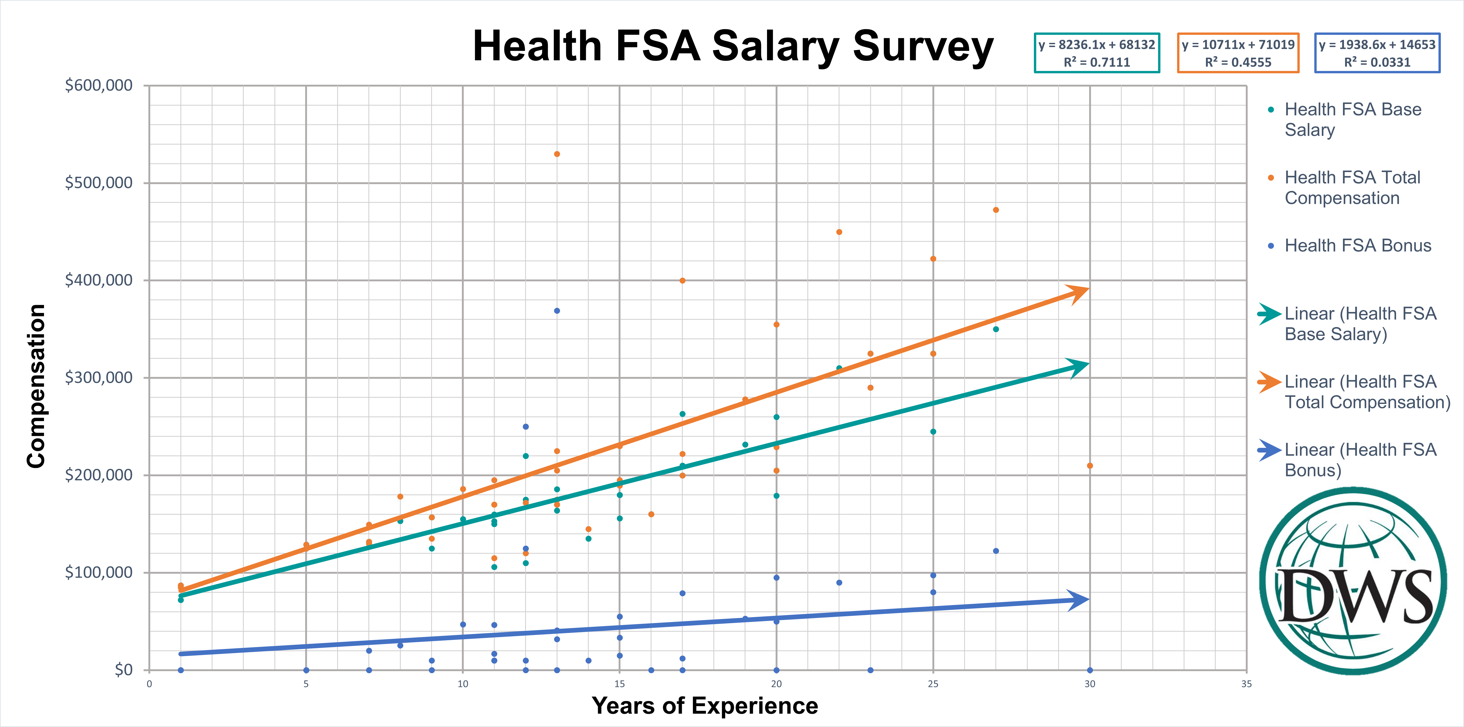

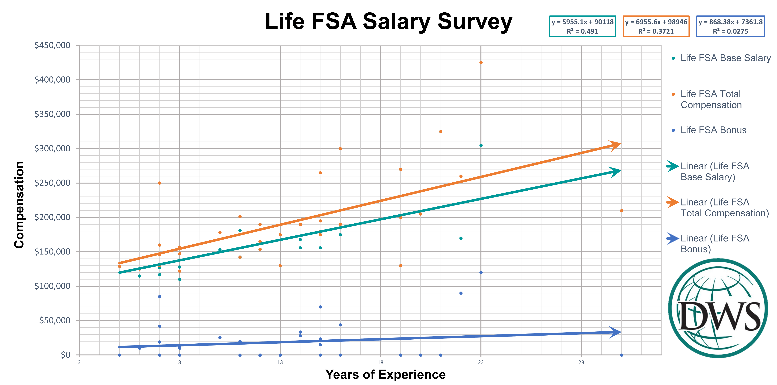
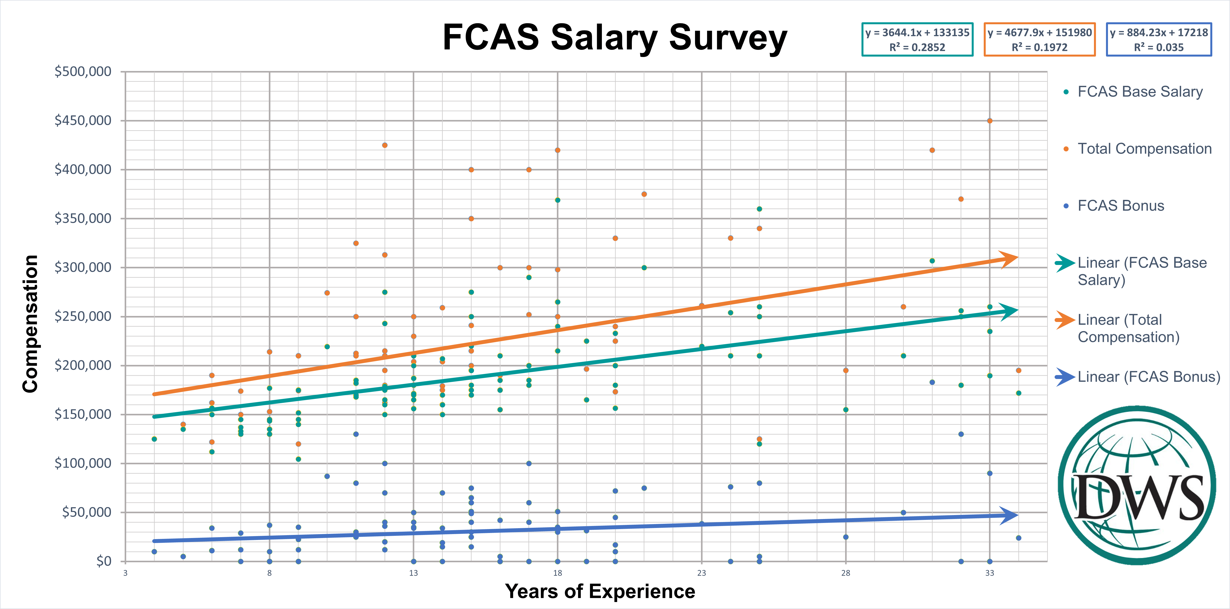

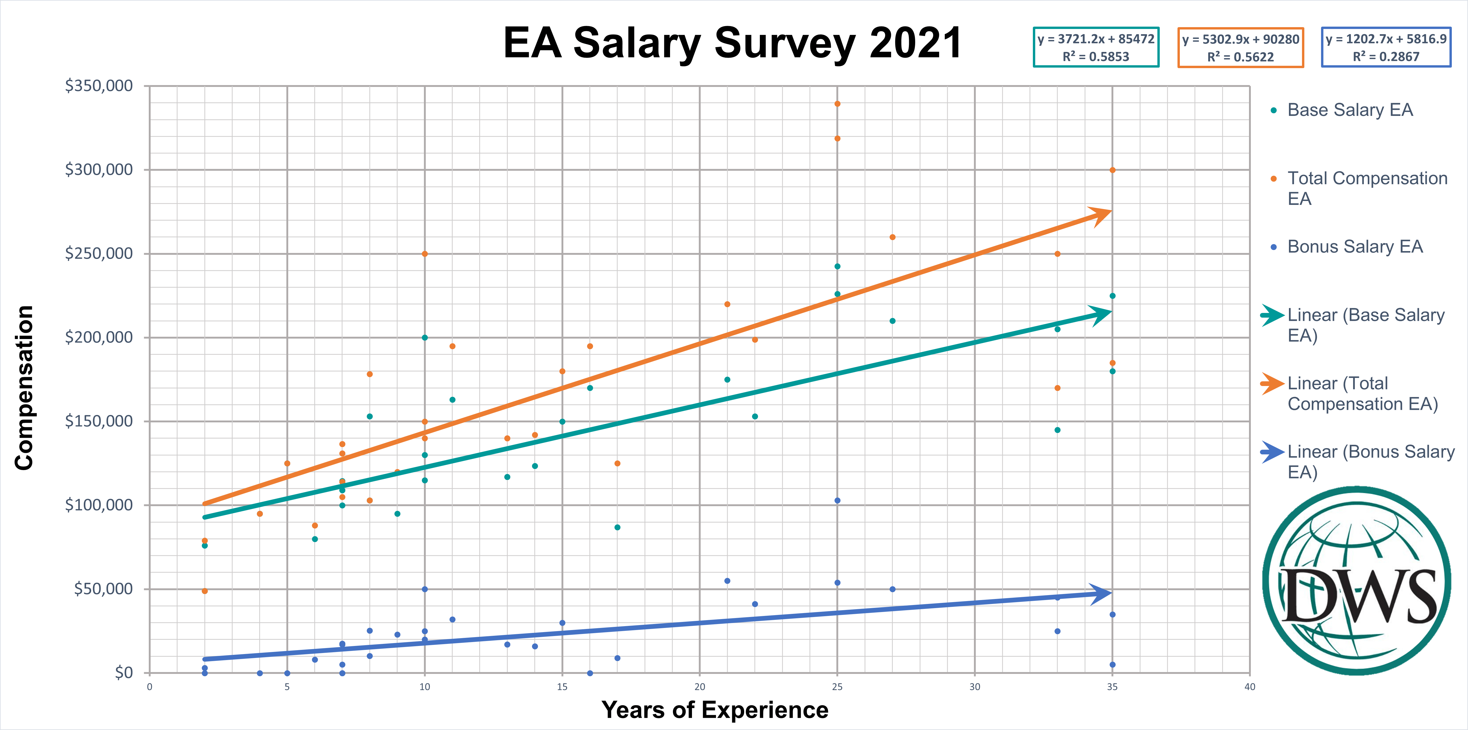

The chart below from the Actuarial Careers Survey of October 2021 shows the average bonus by actuarial practice area. The average bonus incentive is in the $40k-$50K range when averaged in total.

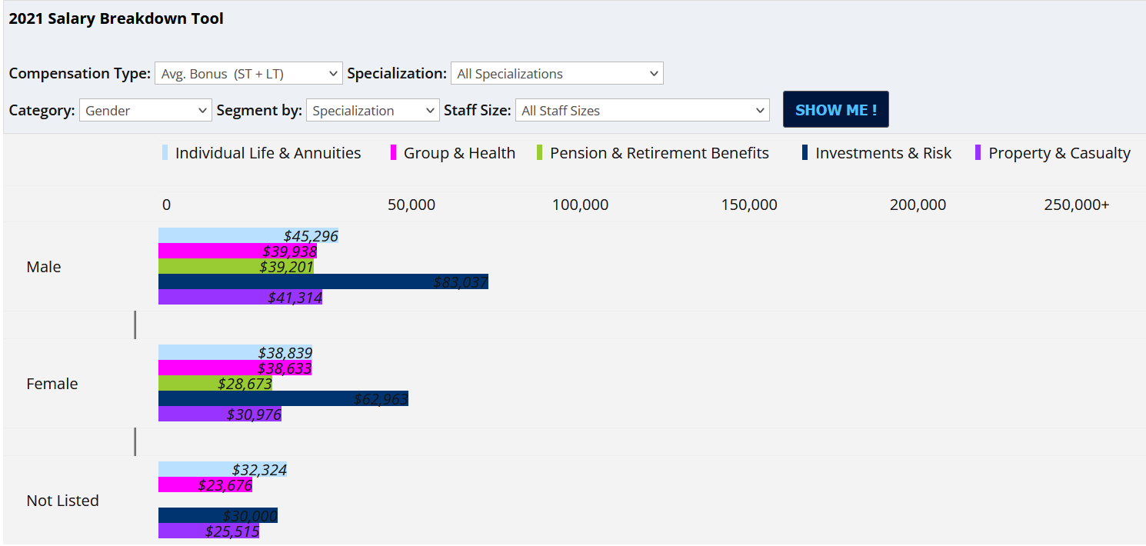

The chart below shows the compensation breakout of a mid-career (16-20 year) actuary with the type of experience State agencies would hope to attract. The average incentive pay is about $68,000 which is 35% of average base salary.

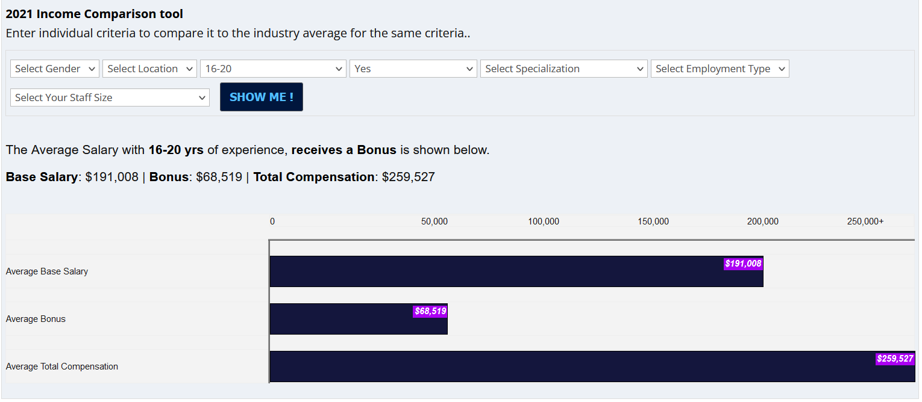

A review of marketplace salary surveys suggests that incentive awards typically range from 0% - 40% of an employee’s base salary, with public or local awards, when applicable, expected to be in the lower half of the reported data.

Similar incentive award programs exist for rank & file Investment Officers in State employment at CalPERS and CalSTRS through Pay Differential 361. Rank and file actuaries at State Compensation Insurance Fund are also currently eligible for an incentive award of up to 8% based on operational and organizational goals.

Timeframe

Any recommendations contained herein are non-binding and are subject to the collective bargaining process between the State and the Union. The current MOU expires June 30, 2023.

Recommendations

Incentive Award Program
The Incentive Award Program shall be developed and administered in accordance with departmental policy and criteria. It is designed for employees in the Actuary Series employed at the State agencies referenced previously and subject to each agency’s objectives as authorized by the department.
- Any award shall be tied to the fiscal year performance period, as defined by the department, and would be based on both quantitative and qualitative criteria to be developed by each department. Such criteria may include performance factors, key metrics for eligibility, award guidelines, approval, and measurable objectives based on the accomplishment of specific outcomes that an actuary has significant control over.

- Any award shall be treated as bonuses would not become part of an employee’s base pay and would not be part of the calculation of final compensation for retirement.

Credential Incentive Pay
    - Credentials have demonstrated value to the State when those credentials are above and beyond the required qualifications for entrance to the classification, especially if they are industry recognized as identifying an individual with exceptional knowledge, skill, or ability. It is recommended that a credential-based bonus or a differential be considered for attracting highly qualified candidates into State Civil Service.

Jarvis v. Cory (1980) 28 Cal 3d 562 San Joaquin Employers’ Assn., Inc. v. County of San Joaquin (1974, Cal App 3d Dist) 39 Cal. App 3d 83 Sturgeon v. County of Los Angeles (2008, 4th Dist) 167 Cal App 4th 630
https://www.bls.gov/ooh/math/actuaries.htm
https://www.forbes.com/sites/forbestechcouncil/2021/12/29/the-global-actuarial-shortage-and-the-role-automation-can-play/
https://www.wsj.com/articles/actuary-credential-test-exam-bad-odds-11640706082?st=z01ezvhwcqqkzzf&reflink=article_email_share
Unit profile report PDL5991r
Unit profile report PDJ6415r

